

DEPARTMENT OF CSE (DATA SCIENCE)

Event: “Data Analytics and Visualisation: Transforming Data into Insights”

Venue: Falconry Hall Time: 10:00 AM – 12:30 PM

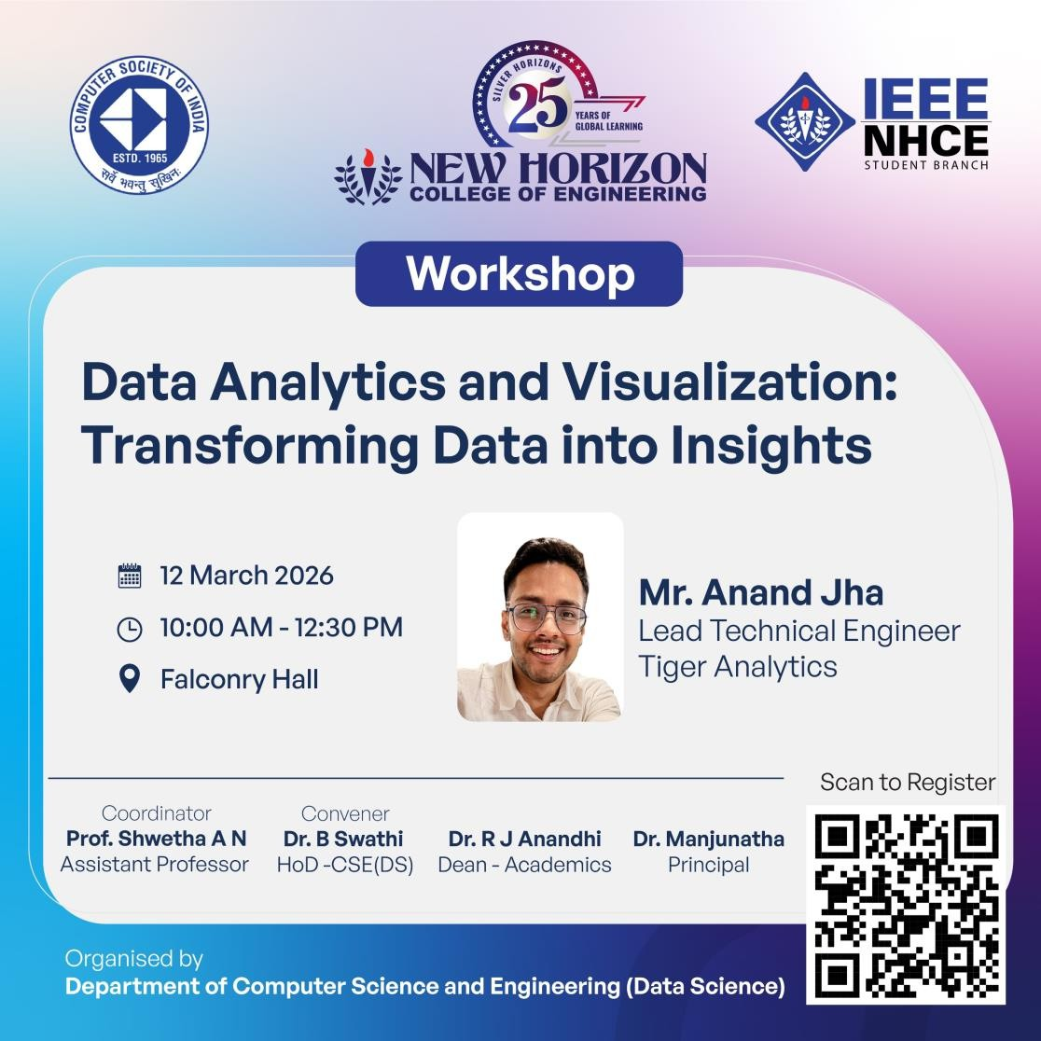

The Department of Computer Science and Engineering (Data Science) at New Horizon College of Engineering organised an informative and engaging workshop titled “Data Analytics and Visualisation: Transforming Data into Insights” on 12th March 2026 at Falconry Hall. The workshop aimed to provide students with a deeper understanding of the growing importance of data analytics and visualisation techniques in modern industries. The session was conducted by Mr Anand Jha, Lead Technical Engineer at Tiger Analytics, who possesses extensive experience in the field of data analytics and business intelligence.
The workshop commenced with a brief introduction to the concept of data analytics and its significance in today’s digital era. Mr Anand Jha explained how organisations across the world are increasingly relying on data to make informed decisions, improve operational efficiency, and gain a competitive advantage. He highlighted that massive volumes of data are generated every day through digital platforms, business transactions, and user interactions. The ability to analyse this data and extract meaningful insights has therefore become a critical skill for professionals in both the technology and business sectors.
During the session, the speaker elaborated on the fundamental concepts of data analytics, including data collection, data cleaning, data processing, and data interpretation. He explained that raw data is often unstructured and difficult to interpret and thus must undergo multiple stages of processing before it can be used effectively for analysis. The importance of data quality, accuracy, and reliability was emphasised as essential for obtaining valid and meaningful analytical outcomes.
One of the major highlights of the workshop was the discussion on data visualisation, which plays a crucial role in presenting complex datasets in a clear and accessible format. Mr Anand Jha explained how visualisation tools help transform raw data into graphical representations such as charts, graphs, dashboards, and interactive visual elements. These representations enable stakeholders and decision-makers to quickly comprehend trends, patterns, and correlations within large datasets.

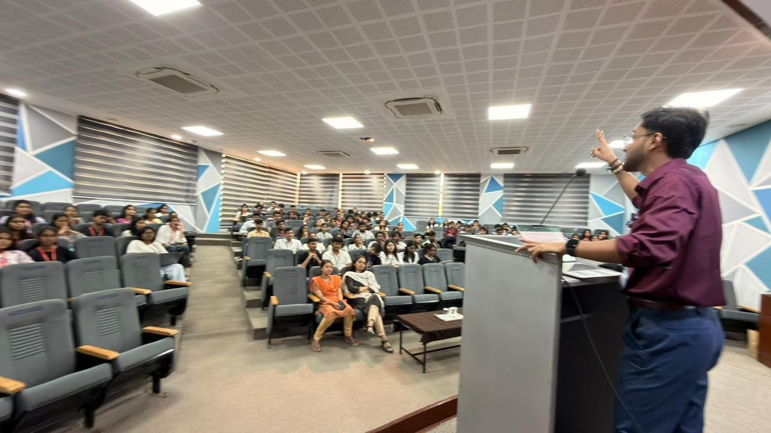
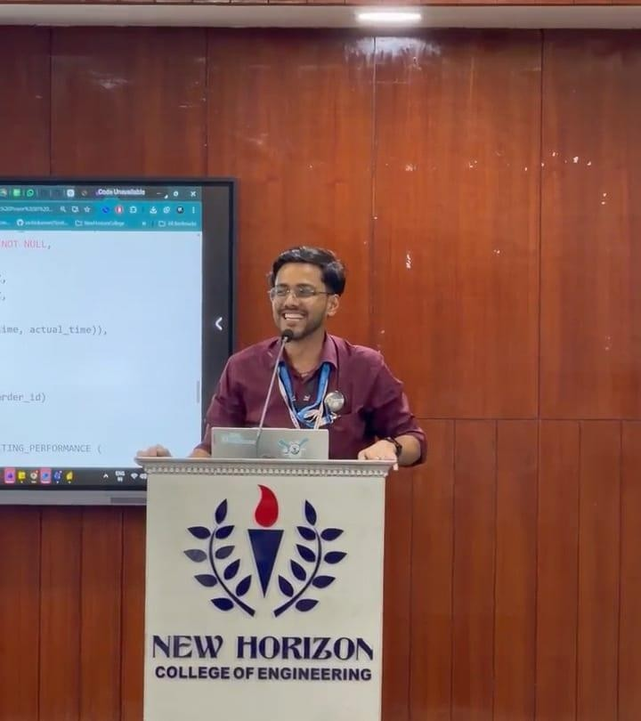

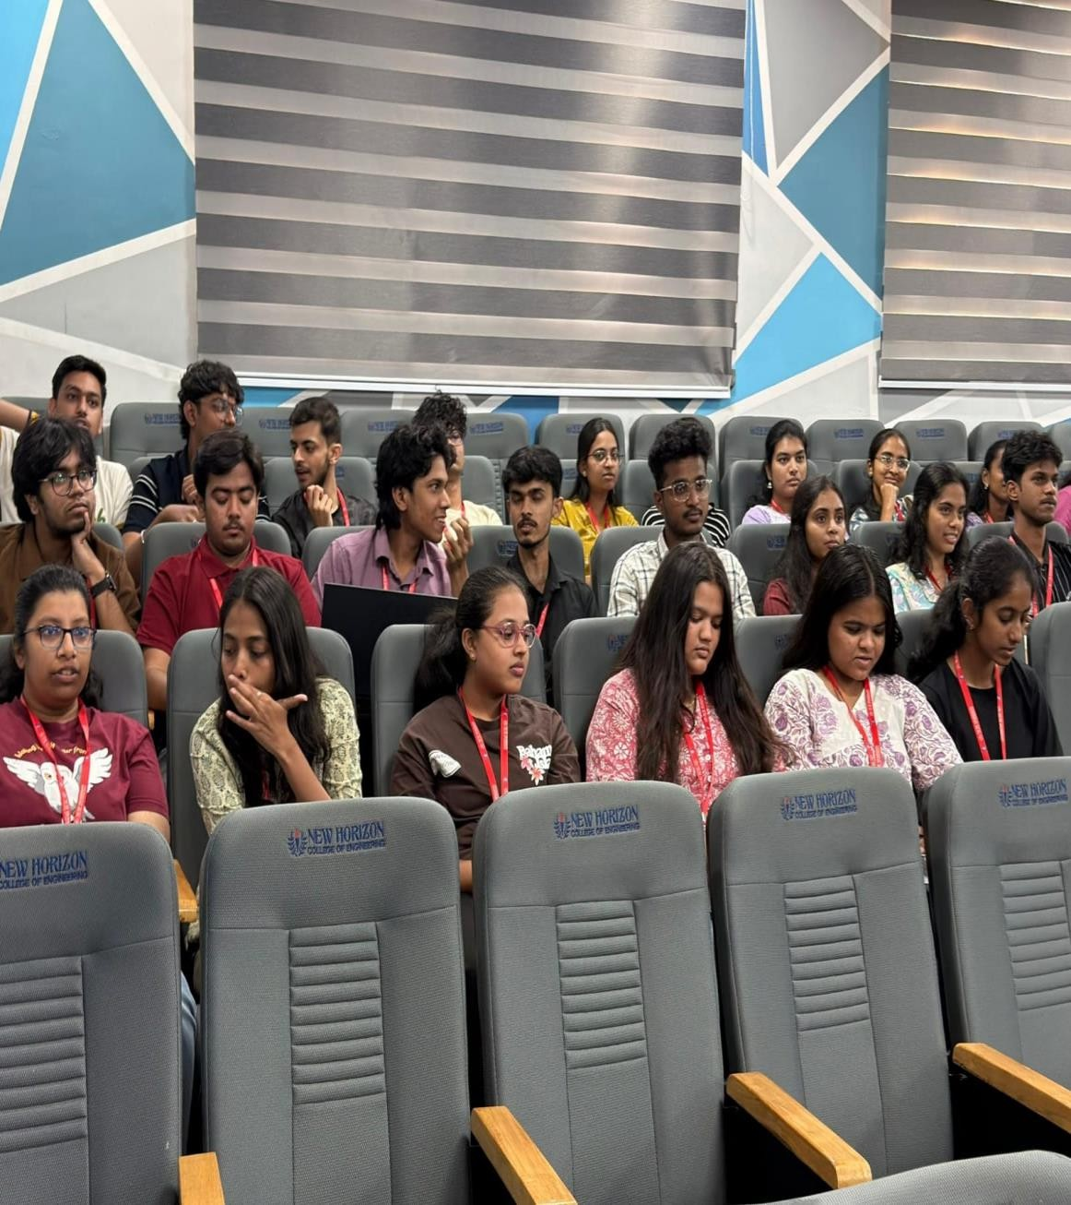

The speaker also discussed the role of modern visualisation tools and platforms used in the industry for creating effective dashboards and reports. He demonstrated how visualisation simplifies communication between technical teams and business leaders by presenting insights in an easily interpretable form. Students were introduced to the importance of selecting appropriate visualisation techniques depending on the type of data and the intended purpose of the analysis.
In addition, the workshop explored real-world applications of data analytics and visualisation across various industries. The speaker shared examples of how companies in sectors such as Finance, Healthcare, Marketing, Retail, and E-Commerce utilise analytics to understand customer behaviour, forecast market trends, improve operational efficiency, and enhance strategic decision-making. These examples helped students understand how theoretical knowledge can be applied to solve practical business problems.
Another important aspect covered during the workshop was the growing demand for skilled data professionals in the industry. Mr Anand Jha emphasised that careers in Data Science, Business Analytics, Machine Learning, and Data Engineering are rapidly expanding due to the increasing reliance on data-driven decision-making. He encouraged students to develop strong analytical thinking, programming skills, and familiarity with data tools to prepare themselves for future opportunities in the field.
The session also addressed some of the challenges associated with data analytics, including handling large-scale datasets, ensuring data privacy, maintaining data integrity, and integrating data from multiple sources. The speaker highlighted the importance of ethical data usage and responsible data management practices. He also discussed how organisations must implement robust systems to protect sensitive information and ensure compliance with data regulations.
Throughout the workshop, students actively participated by asking questions and engaging in discussions about the practical aspects of analytics and visualisation. The interactive nature of the session allowed students to gain clarity on various topics and understand the real-world relevance of the concepts discussed.
Overall, the workshop proved to be highly informative and beneficial for students, providing them with valuable insights into the field of data analytics and visualisation. It helped students understand how data can be transformed into actionable insights that drive innovation and strategic decision-making. The session motivated students to explore further learning opportunities in Data Science and Analytics, encouraging them to build the technical and analytical skills required to succeed in the rapidly evolving technology landscape.



Convener
Faculty Coordinator

HoD-CSE-DS Assistant Prof.

Dr. B Swathi Prof. Shwetha A N

